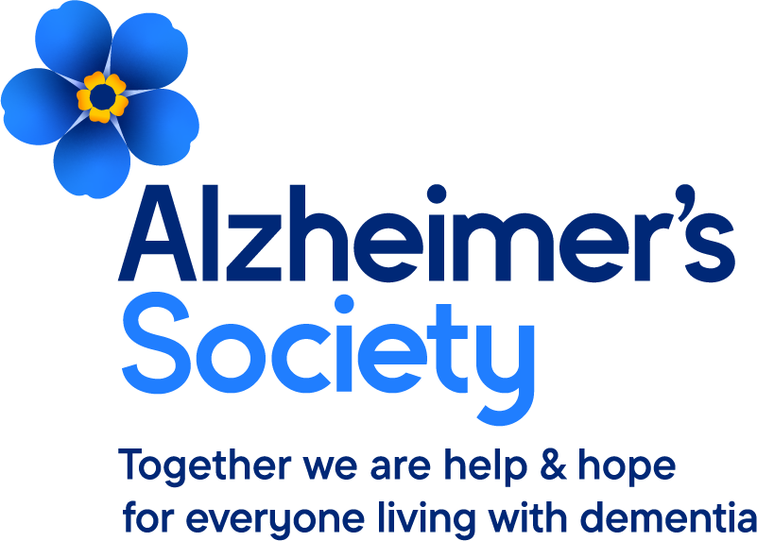

Community Peer Hubs for Dementia – Nottinghamshire
Whether you’ve had a dementia diagnosis or awaiting one, you may be very worried and confused about what support there is available in Nottinghamshire to help you. The Alzheimer’s Society have developed Community Peer Hubs which meet monthly and give you the opportunity to obtain guidance and resources from local services as well as meet and talk to others who are living with or caring for dementia.
A variety of services will be on hand to discuss the support they can offer you including social services, memory group representatives, NHS Talking Therapies, benefit services and social prescribers. Whilst you may not need anything now it will enable you to understand what is available in the future as and when needed.
We would like to invite you to one of our next meetings as shown below. Each hub runs either on a Tuesday (Worksop) or Thursday (Kirkby Health Wellbeing Centre, Edwalton Manor Care Home) 11am to 1pm and parking and refreshments are available. If you are unable to attend any of these but would like to access future ones, please let us know and we can get the details of future hubs to you.
Kilton Golf Club, Worksop. S81 0TL  19 May  16 June  21 July  18 August  15th September4  20 October | Kirkby Health & Wellbeing Centre, Kirkby-in-Ashfield. NG17 7AE  21 May  18 June  23 July  20 August  17 September  22 October | Edwalton Manor Care Home. NG12 4DG  7 May  4 June  2 July  6 August  3 September  1 October

We hope to see you there and if you have any queries, please do not hesitate to call us.

Best wishes
Sharon Grocock and Hazel Tengku Chik Melewar
Community Development Coordinators – Bassetlaw Tel: 0333 150 345

